Monday 22nd May 2023
Dear Parents and Carers,

At St Cuthbert’s, we aim to promote personal wellbeing and development through a comprehensive programme of Personal, Social, Health and Economic (PSHE) Education that gives children and young people the knowledge, understanding, attitudes and practical skills to live healthy, safe, productive and fulfilled lives.

From Summer 2021, the Department for Education made Relationships and Health Education (Primary) and Relationships Sex Education and Health Education compulsory in all schools. Parents cannot withdraw their children from this aspect of education.

The programme we use focuses on healthy relationships and keeping children safe in the modern world. It also covers a wide range of topics relating to physical and mental health, wellbeing, safeguarding and healthy relationships. Learning about the emotional, social and physical aspects of growing up, it gives children and young people the information, skills and positive values to have safe, fulfilling relationships and will help them take responsibility for their own well-being. All of the sessions are age-appropriate and meet the needs of all pupils in the class.

What will the teaching of Relationships, Sex and Health Education look like in a Catholic context?
In teaching this subject we will:

- be faithful to the Church's vision of human wholeness whilst recognising the contemporary context in which we live today;
- involve parents as they are primary educators of their child;
- provide a positive view of human sexuality and dignity of the human person;
- equip young people with the ability to make practical judgments about the right thing to do in particular circumstances;
- explore and promote virtues which are essential to promoting respect and dignity;
- deliver in an age appropriate way which reflects the development of the child;
- use cross-curricular work to support the subject;
- be sensitive to the needs of the individual pupil and recognise the mix of pupils with different sexual orientations, genders and family backgrounds in each class;

How will this be delivered?
All teaching in PSHE takes place in a safe learning environment and is underpinned by our school ethos and values. We use a programme from ‘Ten Ten Resources’ called ‘Life to the Full’. This programme has been approved by our Diocese (the Diocese of Hexham and Newcastle) and materials will be made available so you can see what is being taught in class and how to support your child at home. We teach the new RSE material within the context of a Christian understanding of human sexuality rooted in the wisdom and teaching of the Catholic Church. As a Catholic School, we follow the Diocesan Primary Curriculum Framework for Relationships and Sex Education and Health Education which is fully compliant with the statutory requirements as set out above. We would like to make you aware that part of the ‘Making Babies’ module in Year 6 goes beyond the statutory requirements, in so far as it includes one module of sex

education at Year 6 covering how human life is conceived in the womb, including the language of sperm and ova. Parents have the right to withdraw from this part of the module, but not from the lesson on menstruation.

Should you wish to withdraw your child from lesson 2 in the ‘Making babies’ module you will need to do so by notifying me in writing. Please note, this request would have to be made on a year by year basis (the year your child is in Year 6). The school will provide parental support by providing material for you to help children with their learning in this area, and please remember the benefits of this important education being taught in a safe environment. The Department for Education guidance on parental preference refers to potential detrimental effects of withdrawal of a child from these lessons – this could include social and emotional effects of being excluded, as well as the likelihood of your child hearing their peers’ version of what was said in classes, rather than what was directly said by the teacher.

What if I have questions?
Please read our policy published on our website, and our curriculum document, which will show you in detail the modules covered across school from Early Years to Year 6. You can view a sample of the programme and some lessons using the password below.

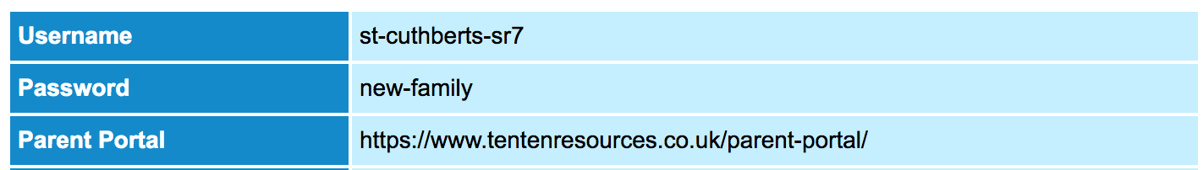

As a school community, we are committed to working with parents and your children in the best way that we can, preparing them for the world in which they live.

Should you have any further questions, please do not hesitate to contact us, but please do read the information carefully and respond to our google form should you have any comments. Any comments should be sent by Monday 19th June.

Yours sincerely,
Mrs N Noble
(RSE Lead)

